**Setting Environment For Dev Environment In Azure App Service**

To set the environment in [Azure App Service](https://azure.microsoft.com/services/app-service/), perform the following steps:

1. Select the app from the **App Services of the Dev Environment** blade.
2. In the **SETTINGS** group, select the **Application settings** blade.
3. In the **Application settings** area, select **Add new setting**.
4. For **Enter a name**, provide “ASPNETCORE_ENVIRONMENT”. For **Enter value: “AzureDev”**

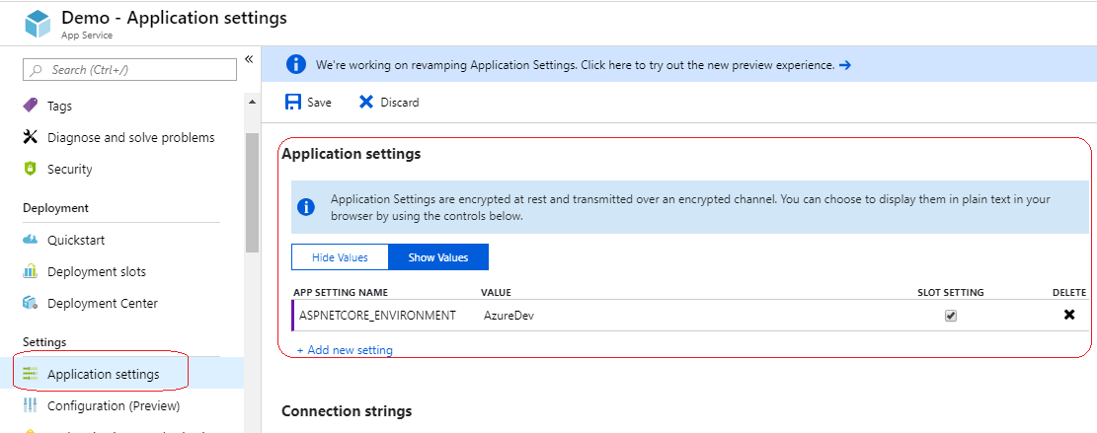

1. Select the **Slot Setting** check box if you wish the environment setting to remain with the current slot when deployment slots are swapped.
2. Select **Save** at the top of the blade.

**Setting Database ConnectionStrings In Azure App Service**

To set the environment in [Azure App Service](https://azure.microsoft.com/services/app-service/), perform the following steps:

1. Select the app from the **App Services of the Environment** blade.
2. In the **SETTINGS** group, select the **Application settings** blade.
3. In the **Application settings** area, select **Add new setting**.
4. For **Enter a name**, provide “ConnectionStrings:MainDb” . For **Enter value:** *Enter the database connectionstring*

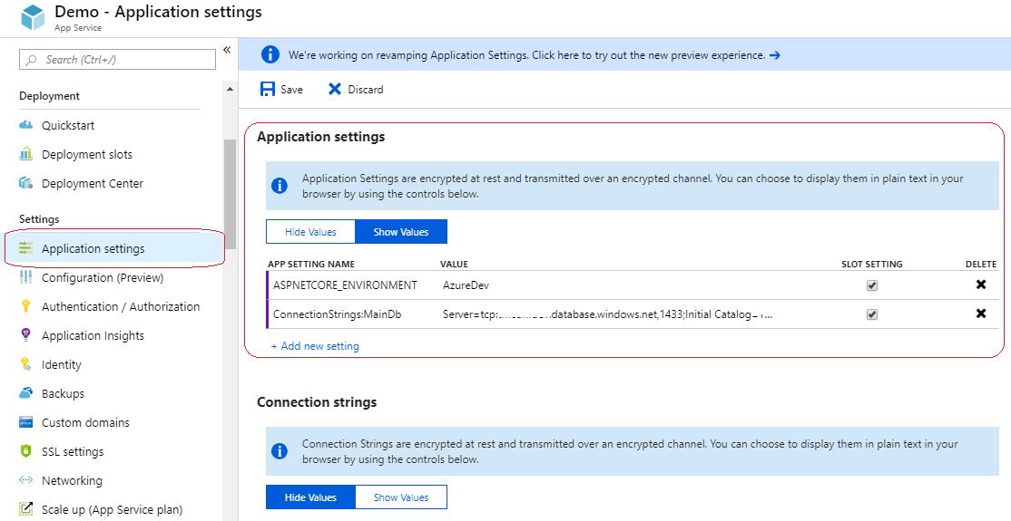

1. Select the **Slot Setting** check box if you wish the environment setting to remain with the current slot when deployment slots are swapped.
2. Select **Save** at the top of the blade.